Maven

https://www.youtube.com/watch?v=0CFWeVgzsqY

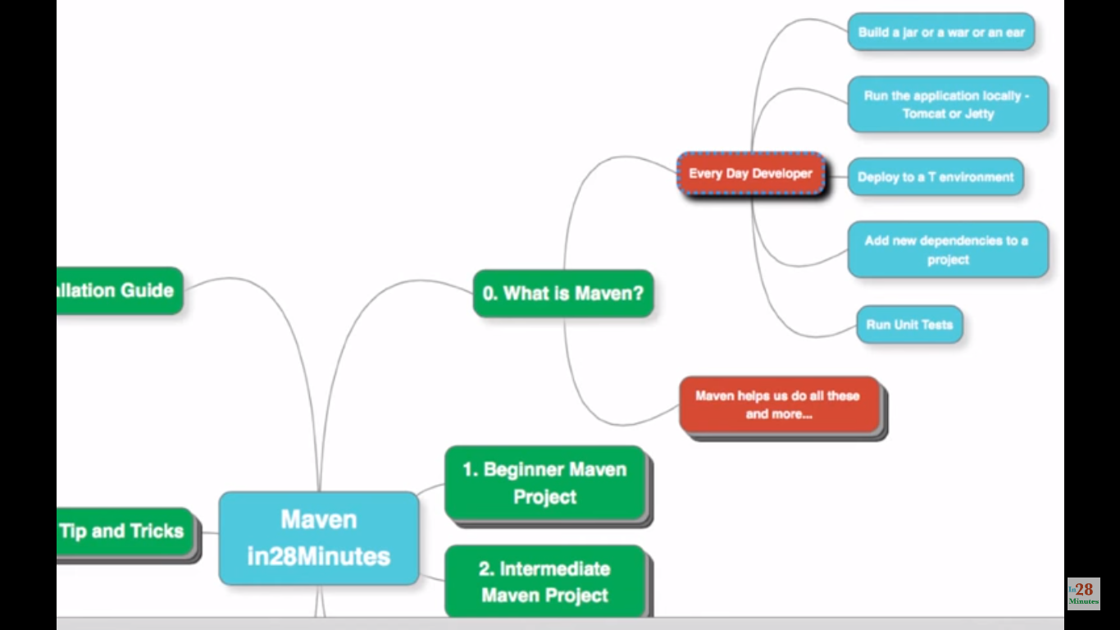

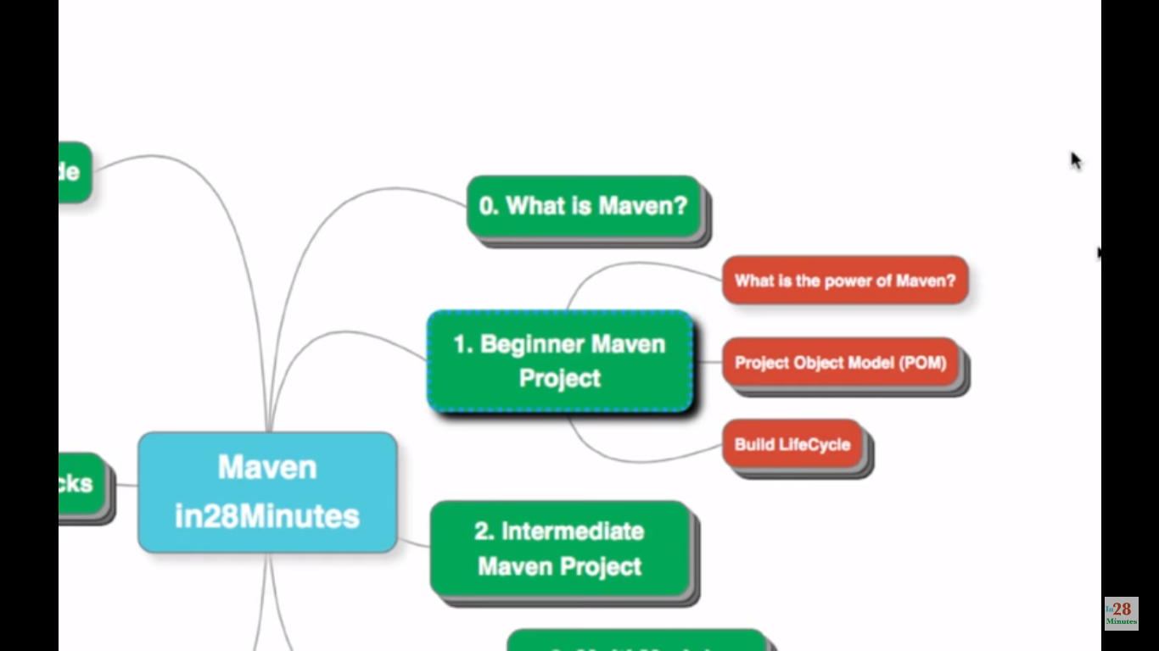

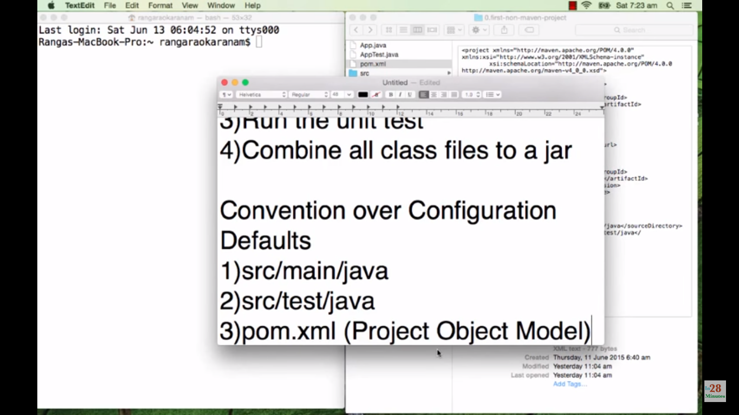

Follow these folder structure to keep the source java files and test files respectively. This is the default class paths for maven project. We can override it if we need.

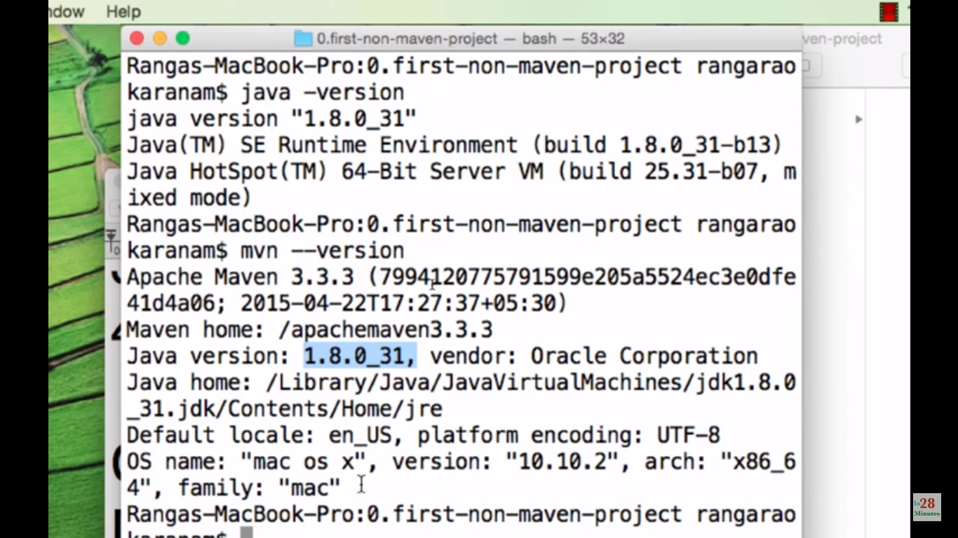

We are in project folder now. Check java and maven is installed properly.

Cmd - > mvn compile. Compiles the src and test files and create a folder target, which contains class files.

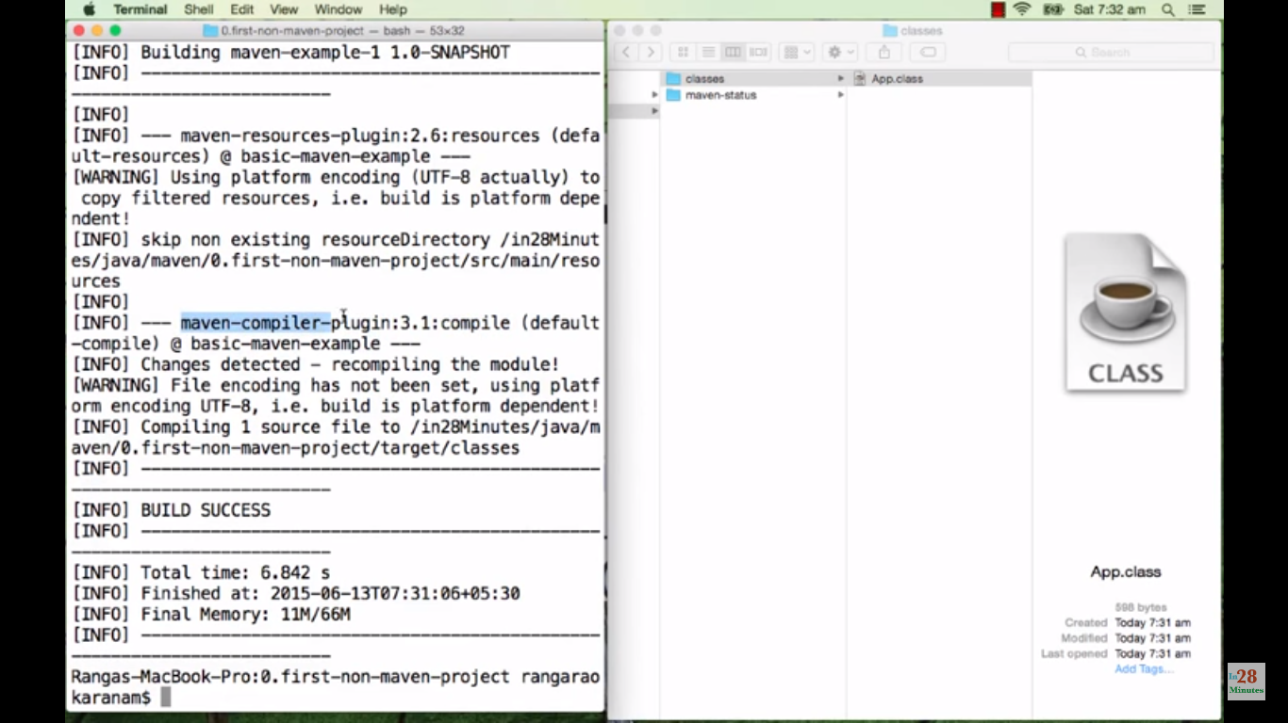

Cmd - > mvn test-compile to compile test files (but also source files will be compiled before to that)

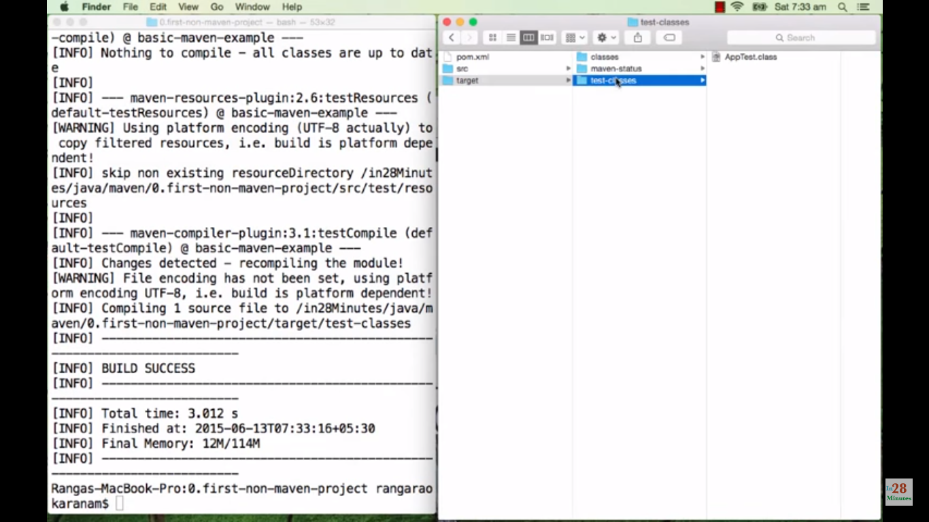

Mvn clean -> to clean the maven directory. Target directory will be deleted.

Mvn test – to run the junit test files.

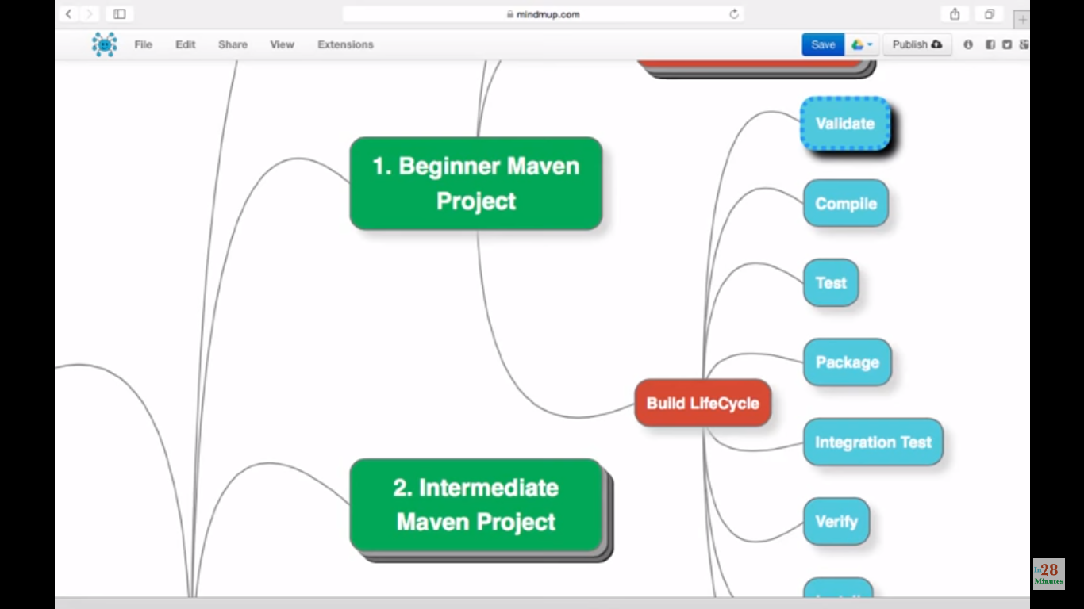

If we do **mvn test**, it will do automatically validate, compile and finally test. In the same way **mvn install** will do all the previous steps and finally it will install.

We can define, run this plug in for test and run this plugin for verify etc.,

Mvn install :

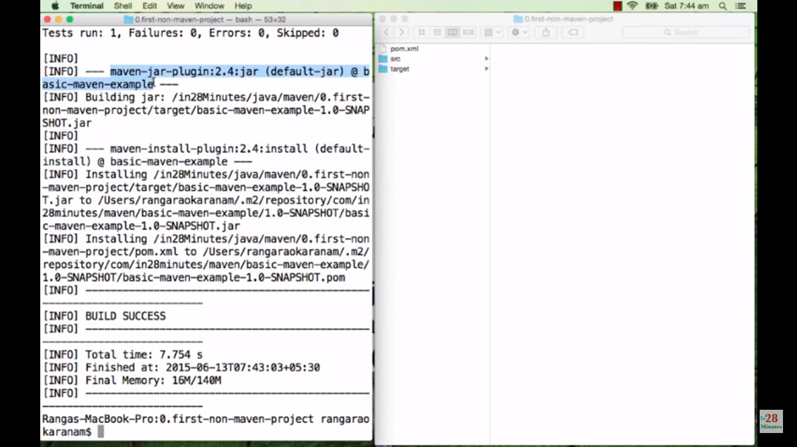

Generating jar file is called packaging.

Installed in local maven repository.

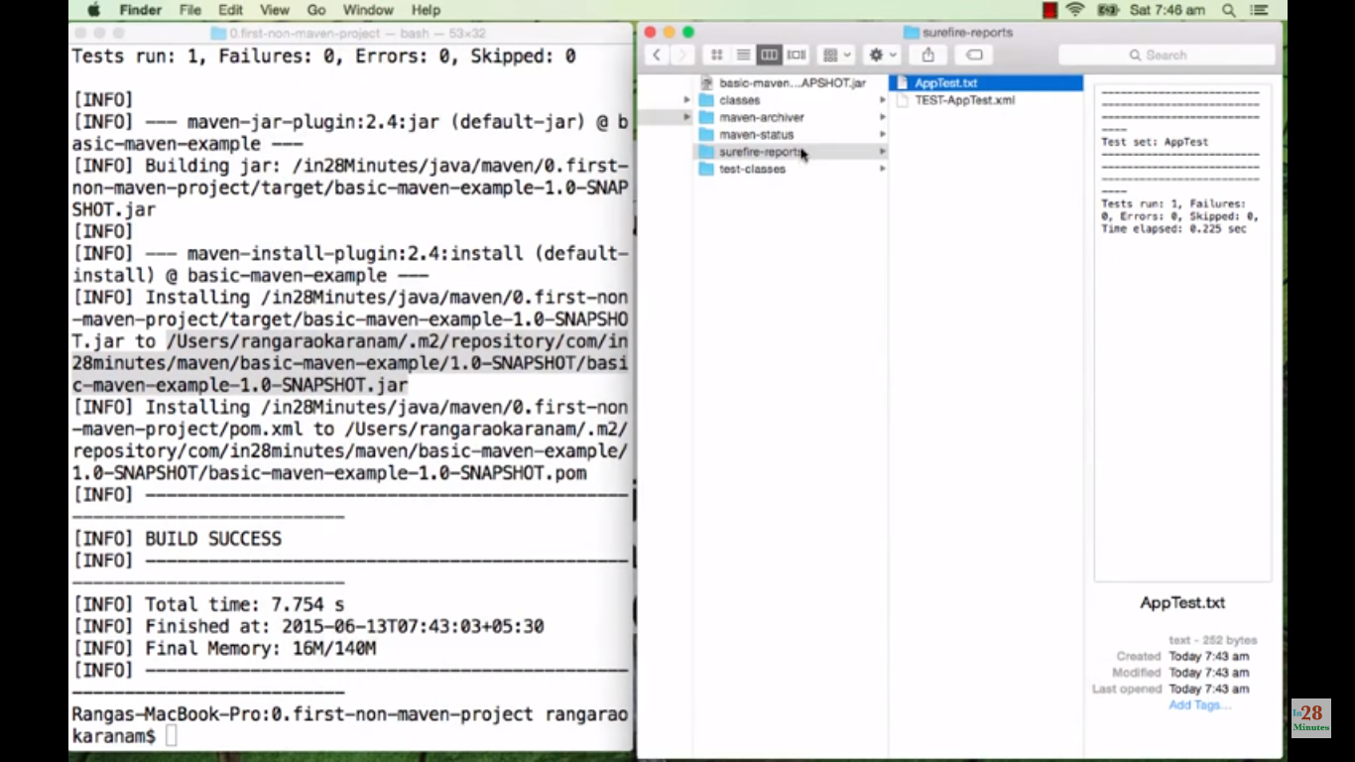

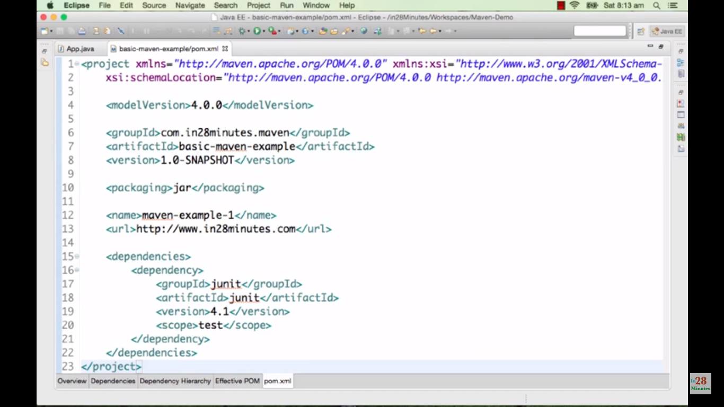

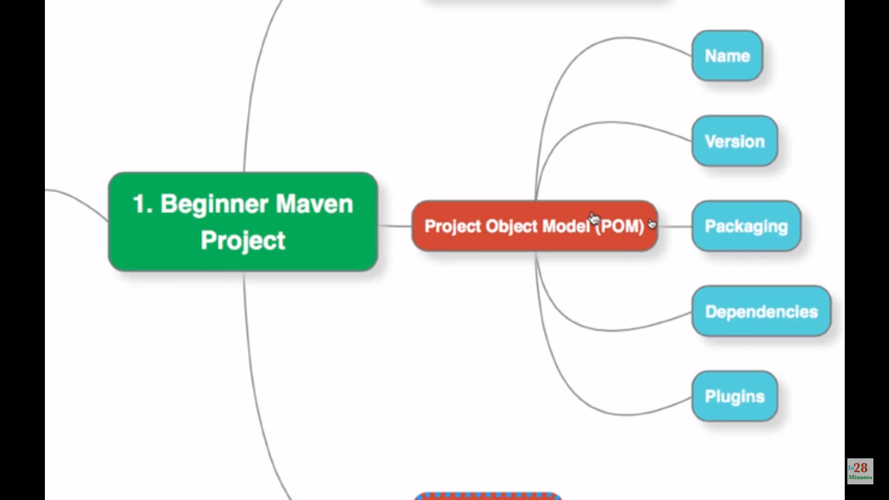

Plugins – if we would like to install the application in tomcat, which maven plugin (tomcat mvn plugin) we need to use to achieve that.

Name – will be used by other projects to make use of this project. Name is the combination of group id and artifact id. Snapshot meaning version in development.

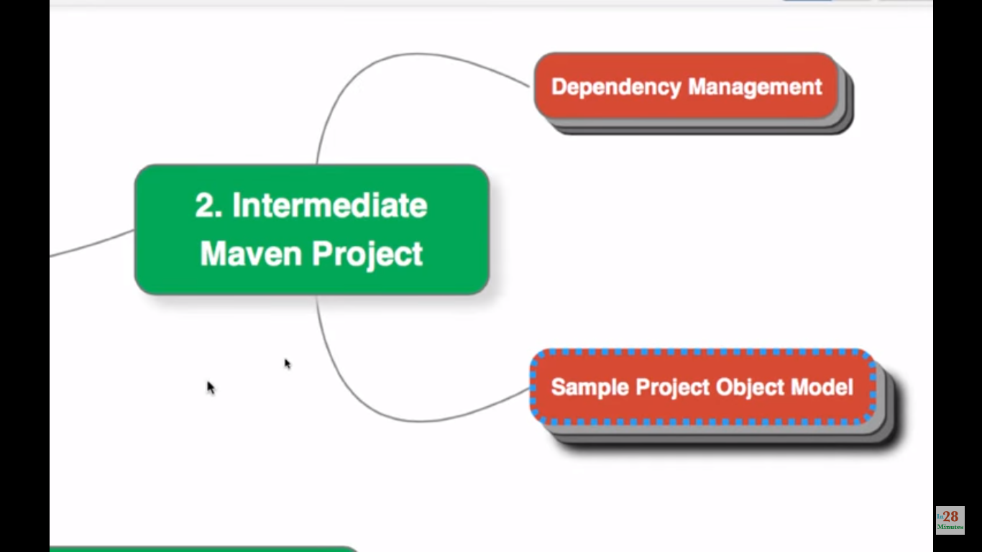

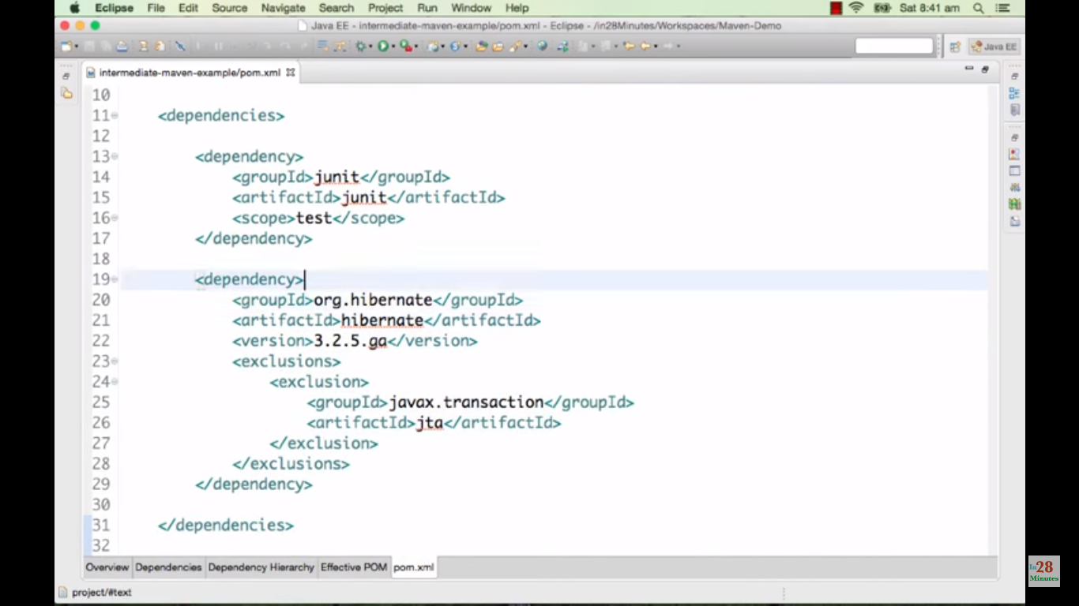

Transitive dependencies – hibernate depends on other projects (or libraries).

Exclusions – if we would like to exclude some dependencies of hibernate, we can define here.

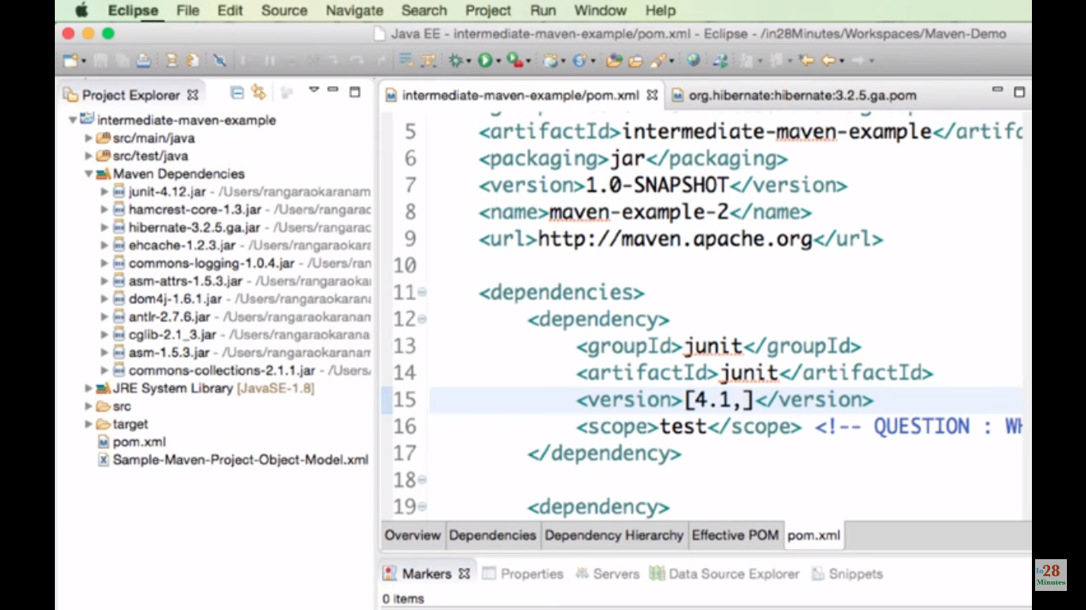

Junit – I can use version greater than 4.1. **[,4.1]** means at the max I can use 4.1. **[,4.1)** means I don’t want to use 4.1, lesser than that is fine (4.0). **[4.1, 4.4]** I can use between 4.1 and 4.4. it will be automatically taking 4.4

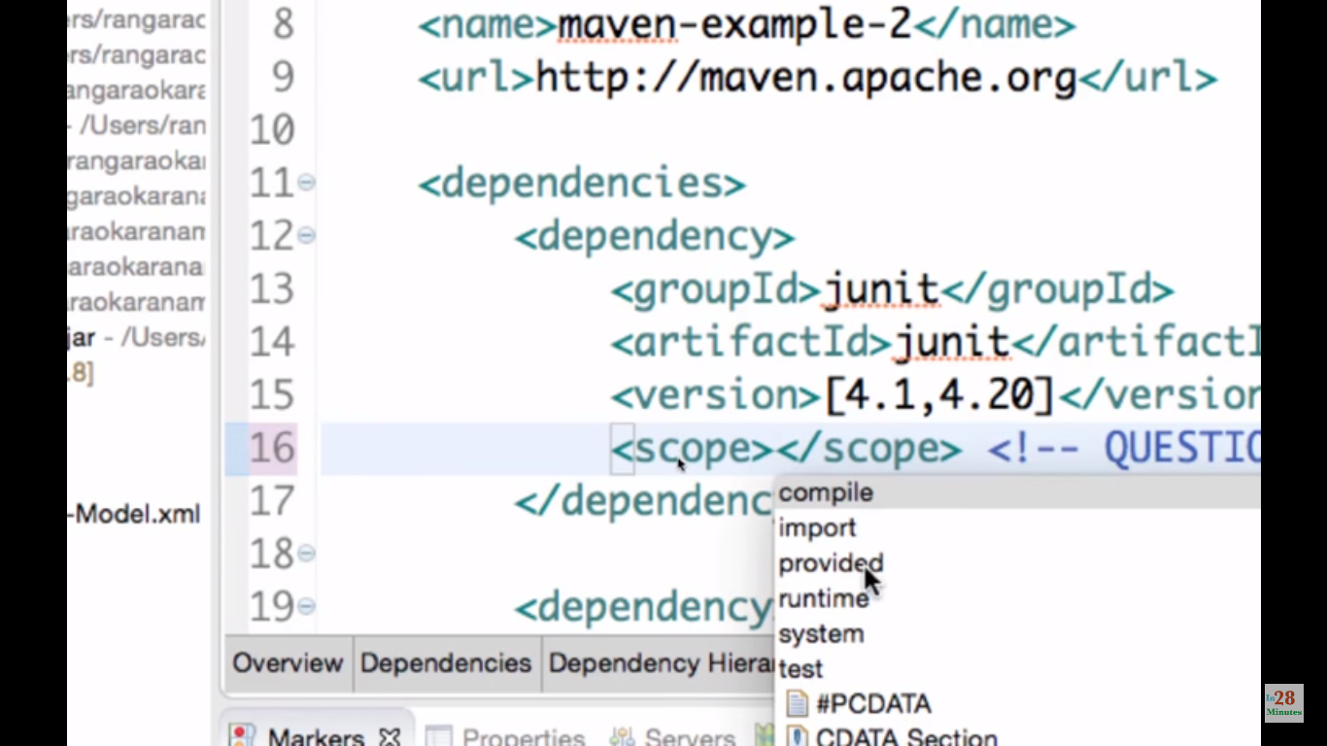

If scope is test then the junit jar file only available for testing. It will not having scope for source files. Note: we can’t create object inside src/main/java folder.

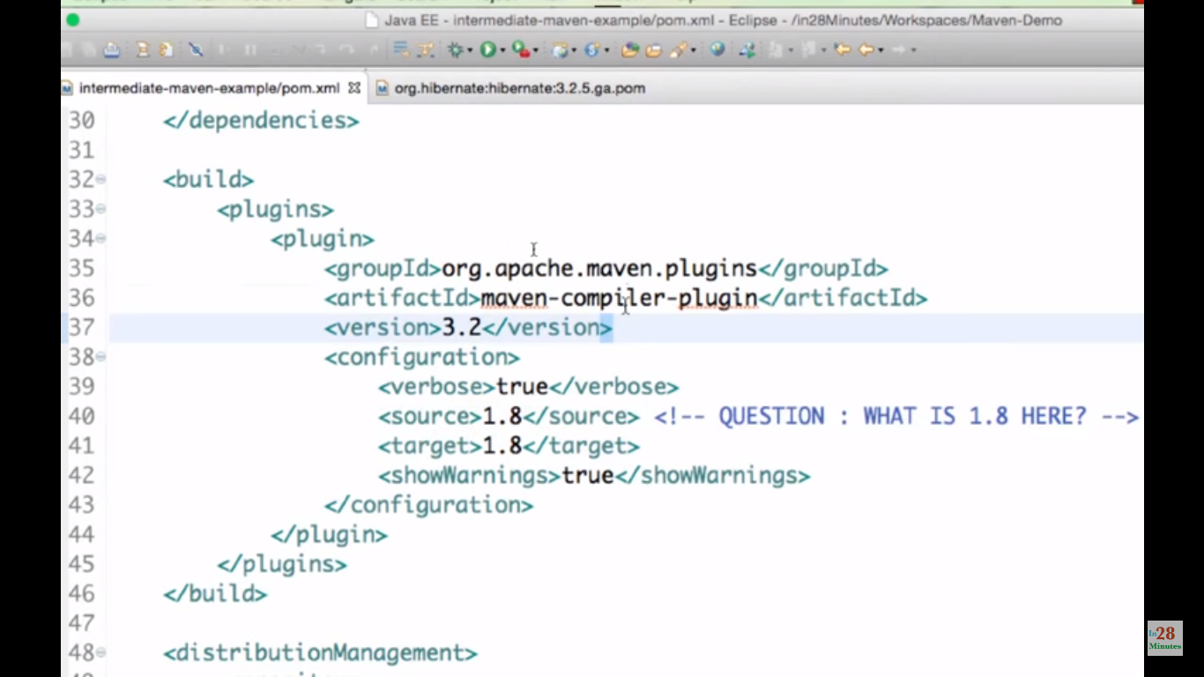

Source and target defines which version of java has to be used.

Pom inherits some properties from super POM (Effective POM).

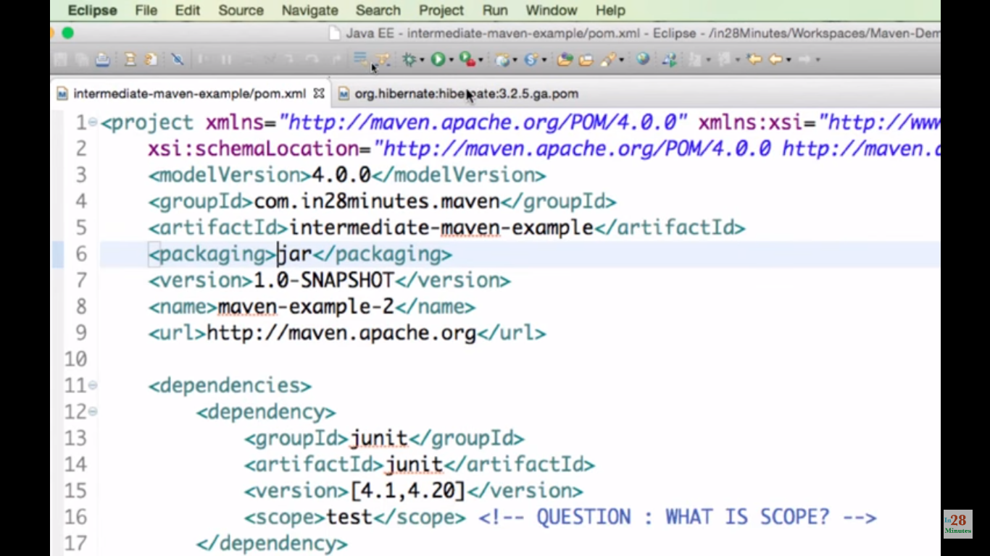

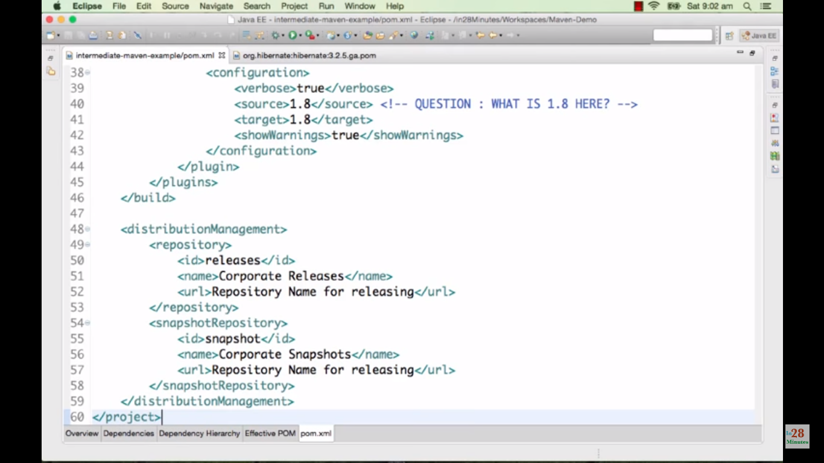

Source directory is over ridden from super pom. If we save here, it will affect super pom as well. If we delete that it will be re-created to default value in super pom.

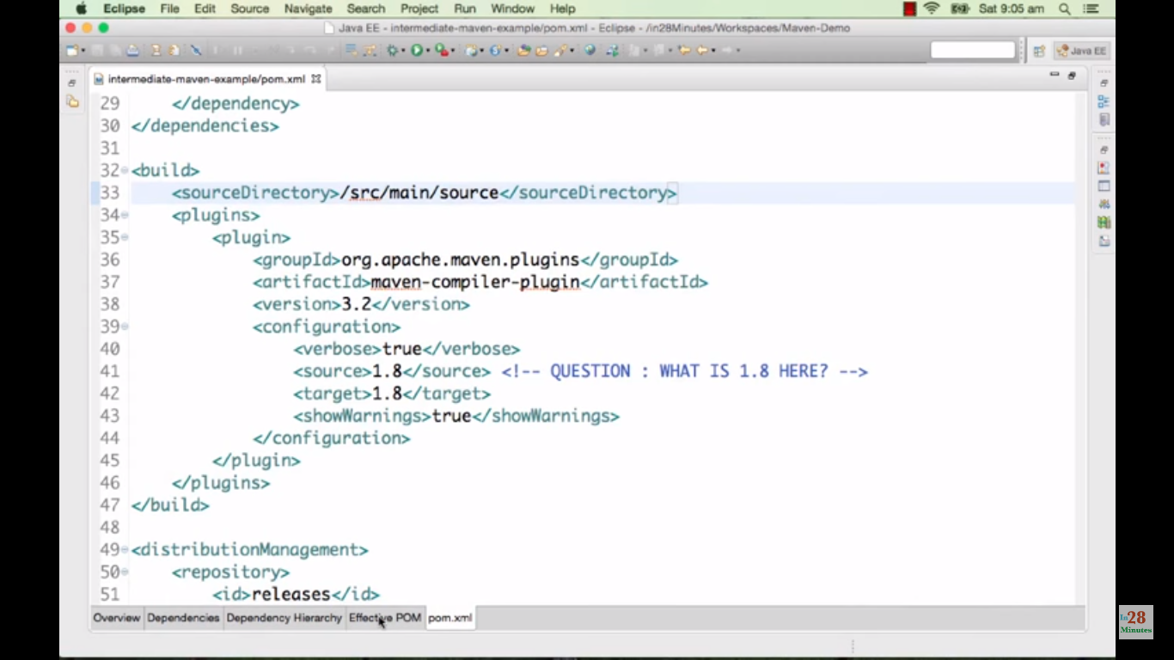

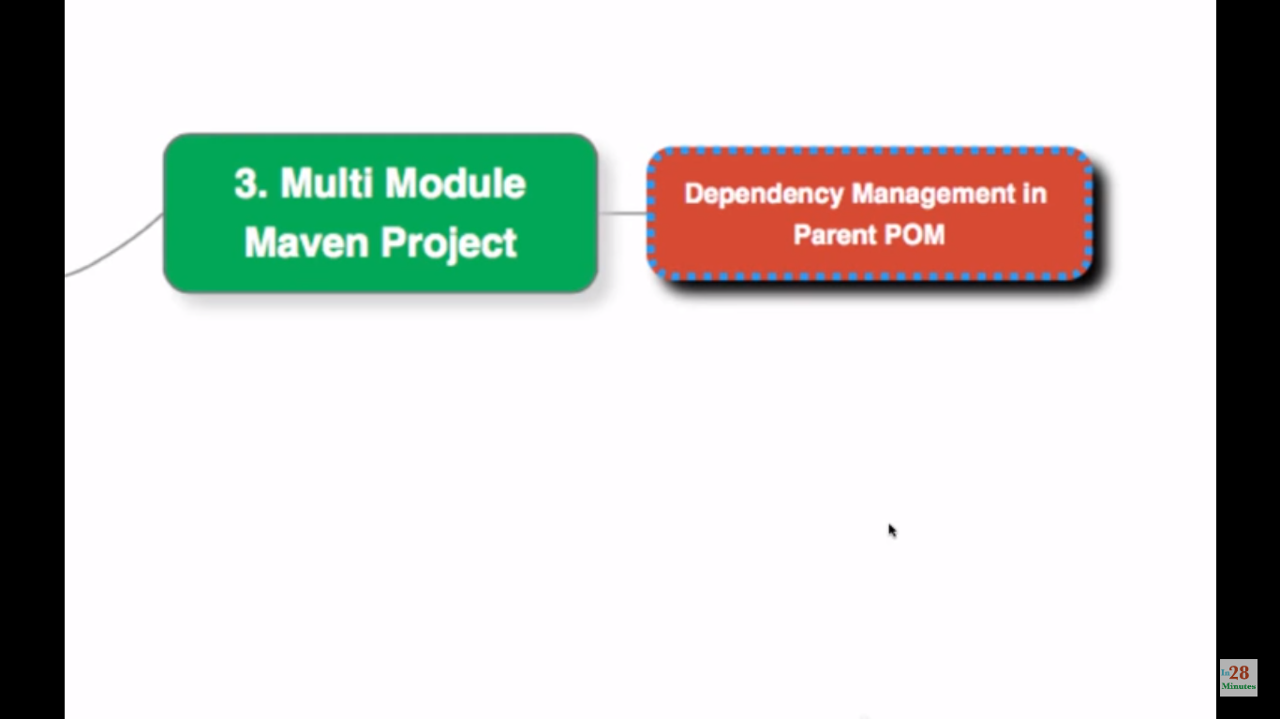

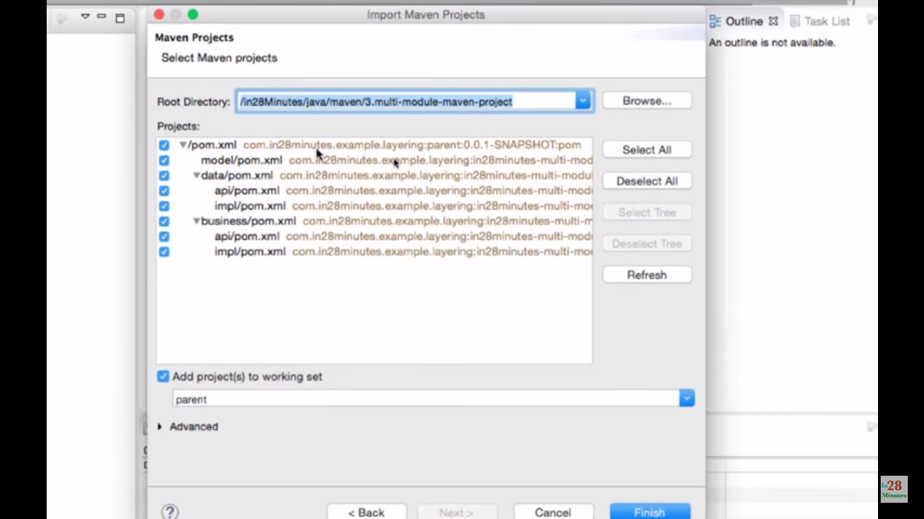

Data layer is depending on Model. Business layer is depending on Data and Model.

Parent pom:

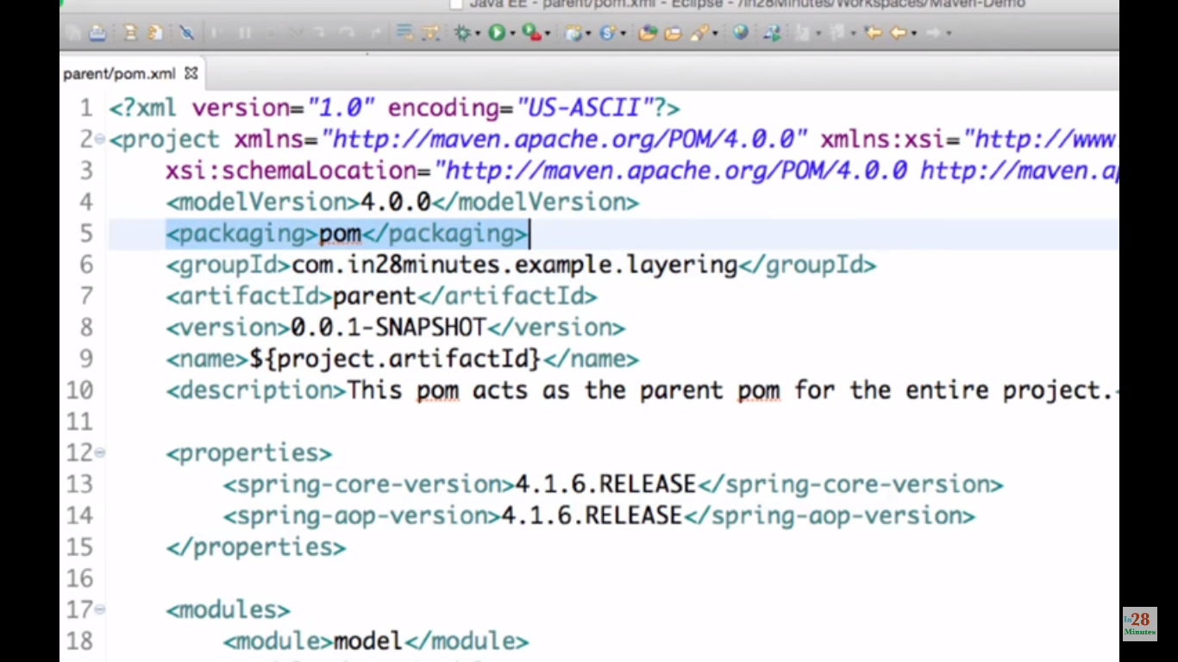

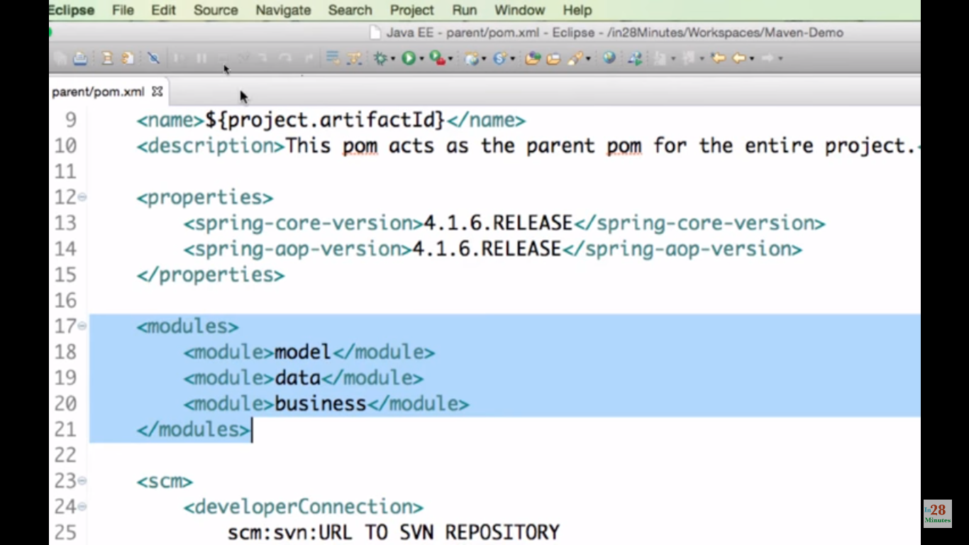

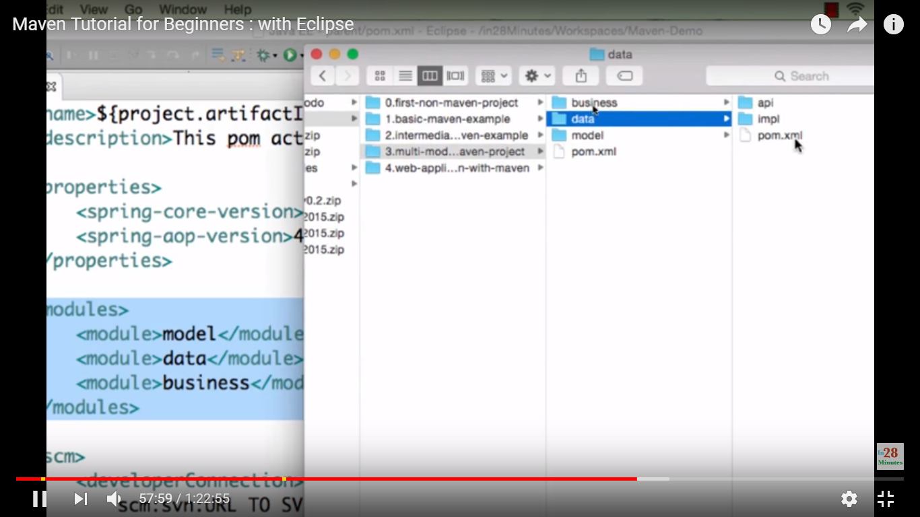

Module names are folder names

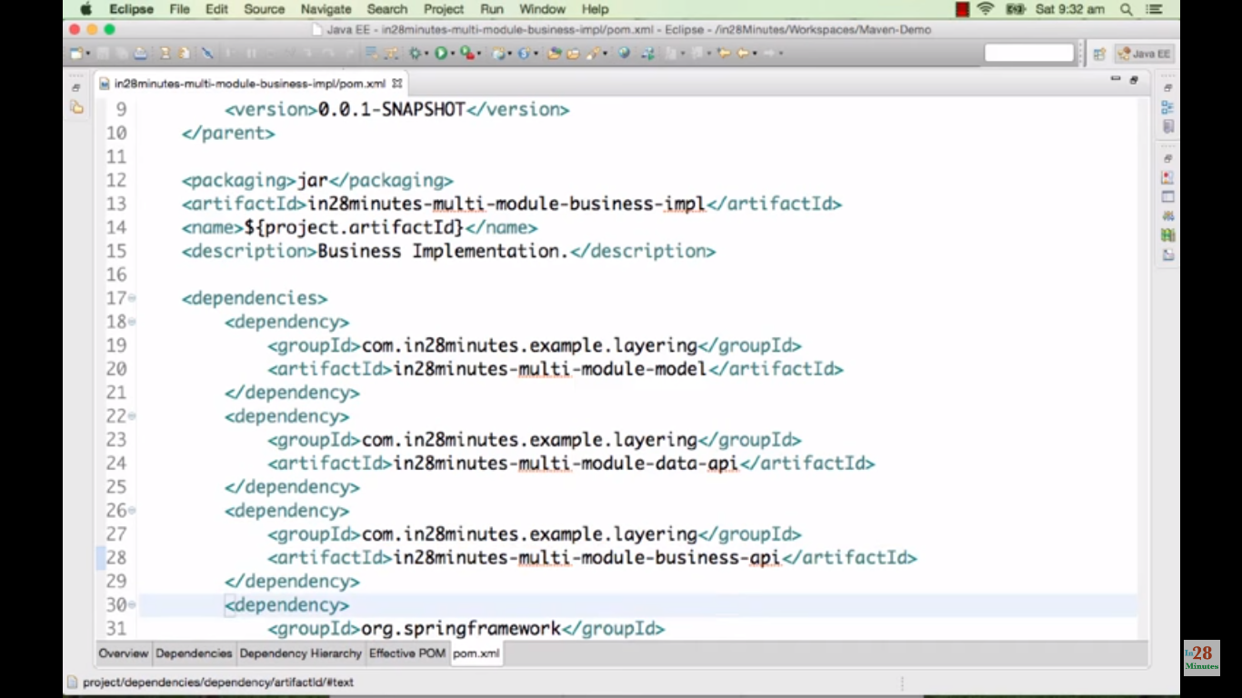

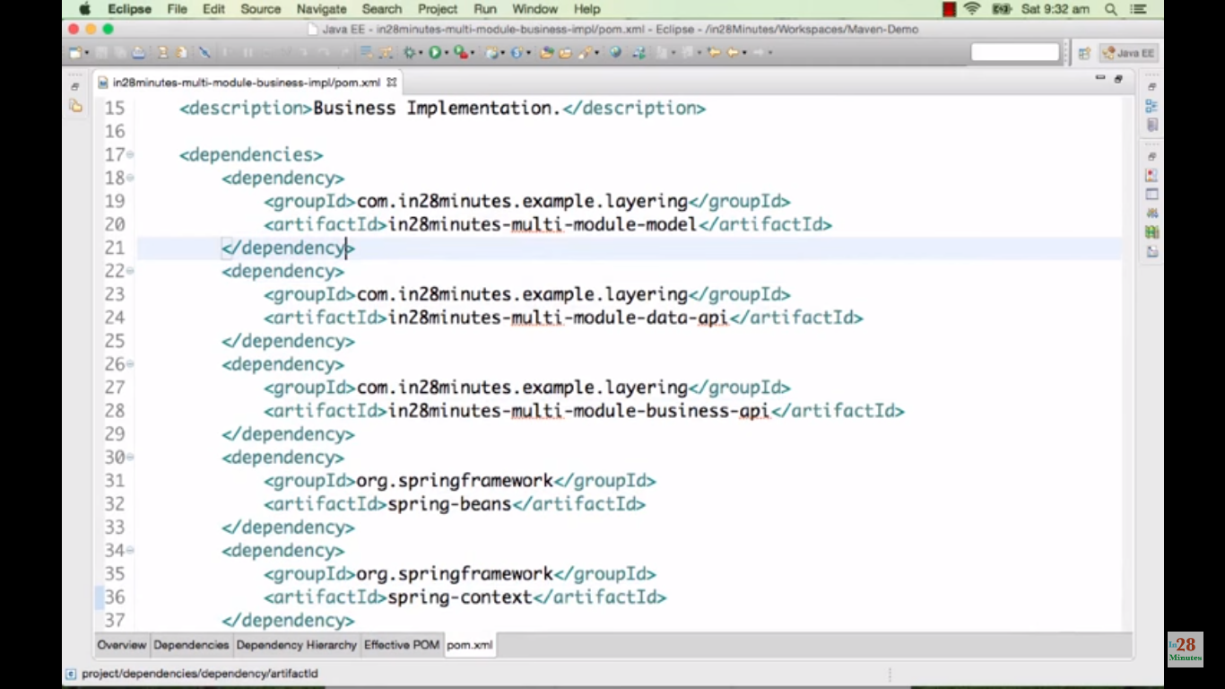

Version numbers are not required here as it gets from parent/pom.xml

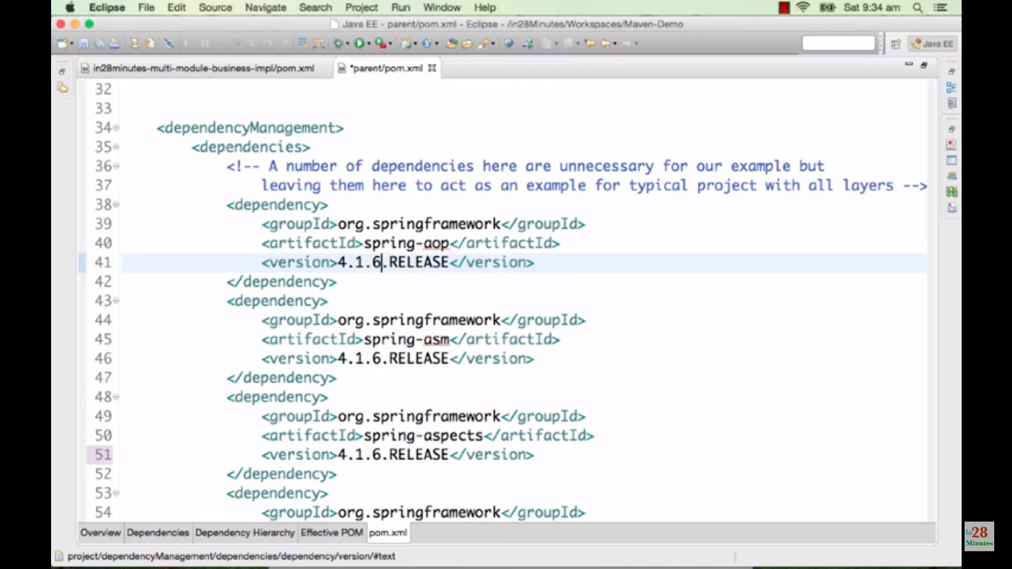

We can go for <properties> to define the version numbers.

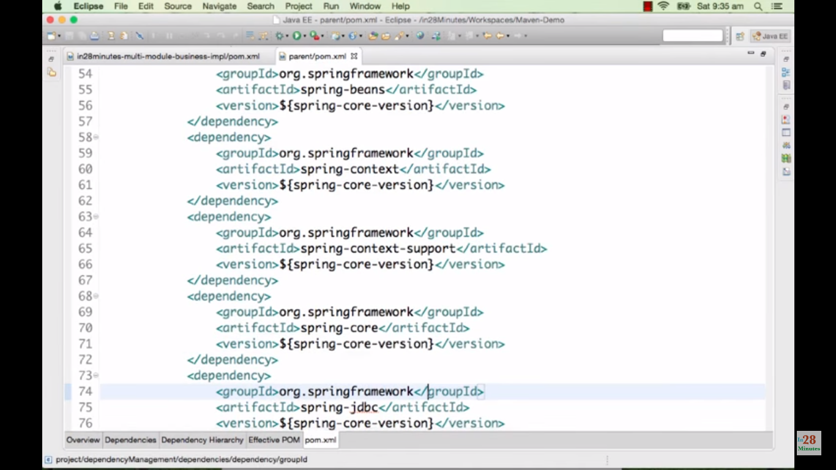

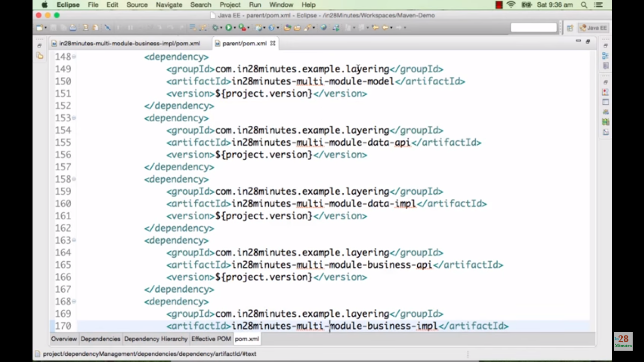

Cmd -> mvn clean install

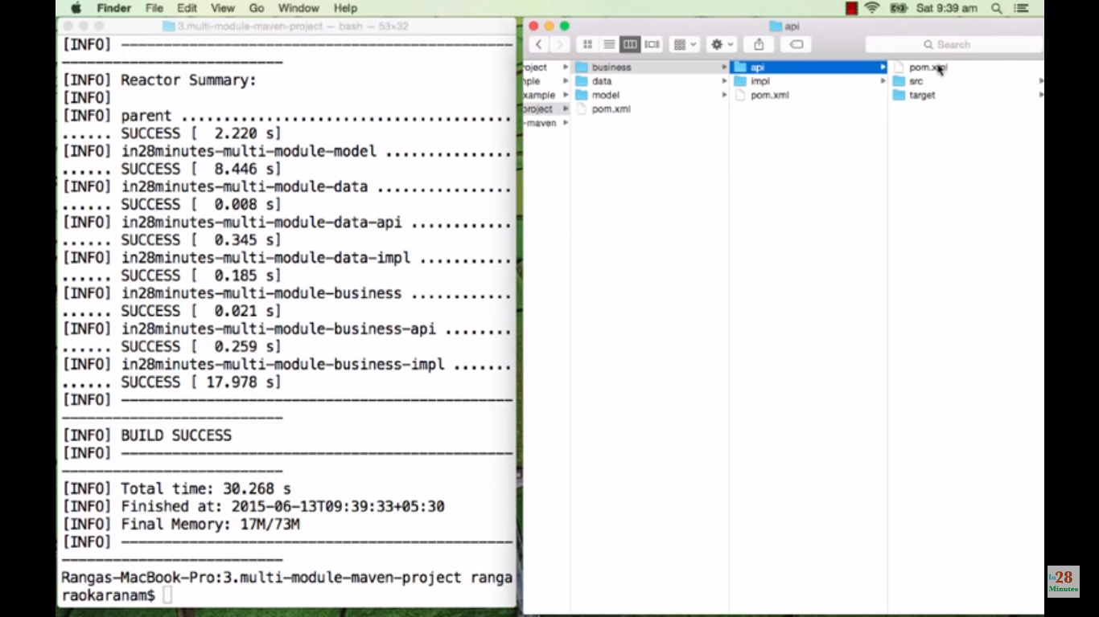

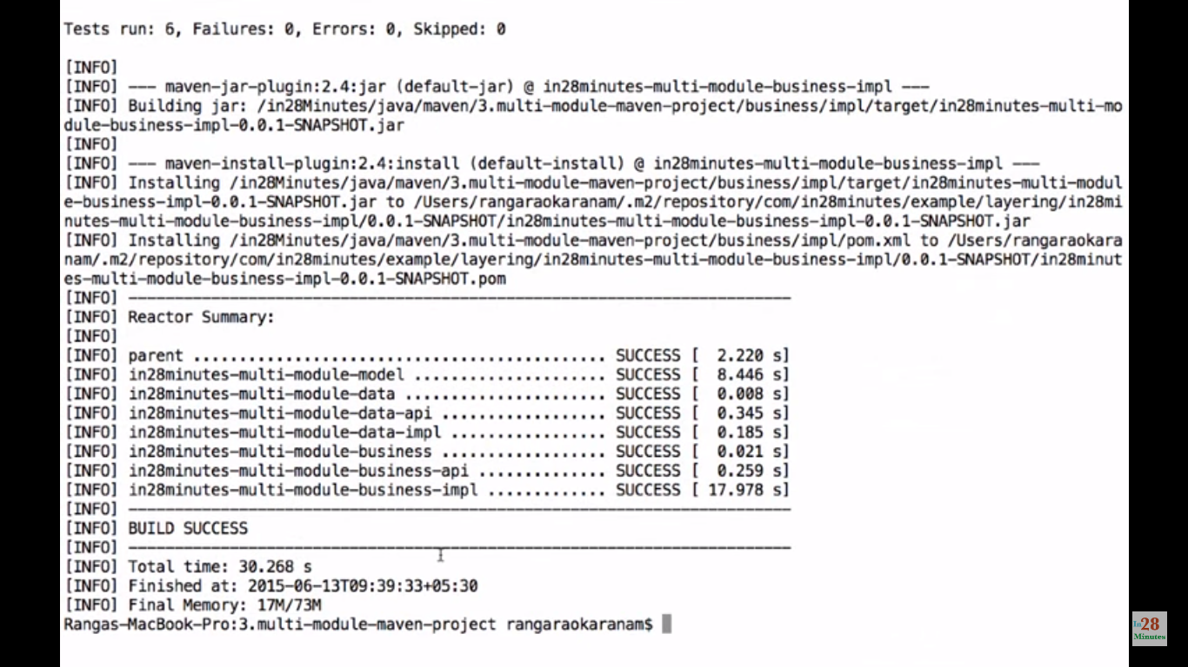

**Web project:**

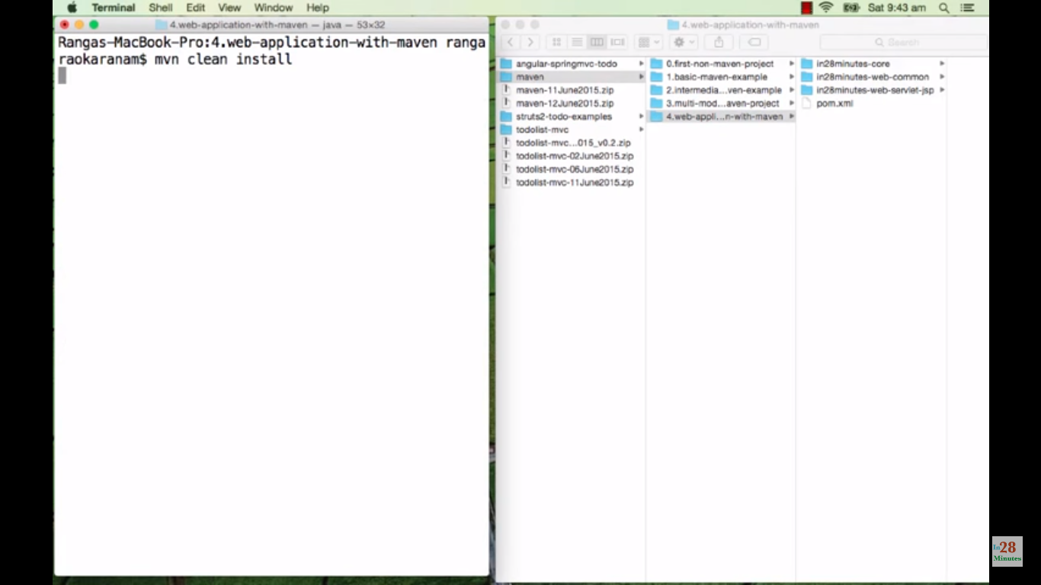

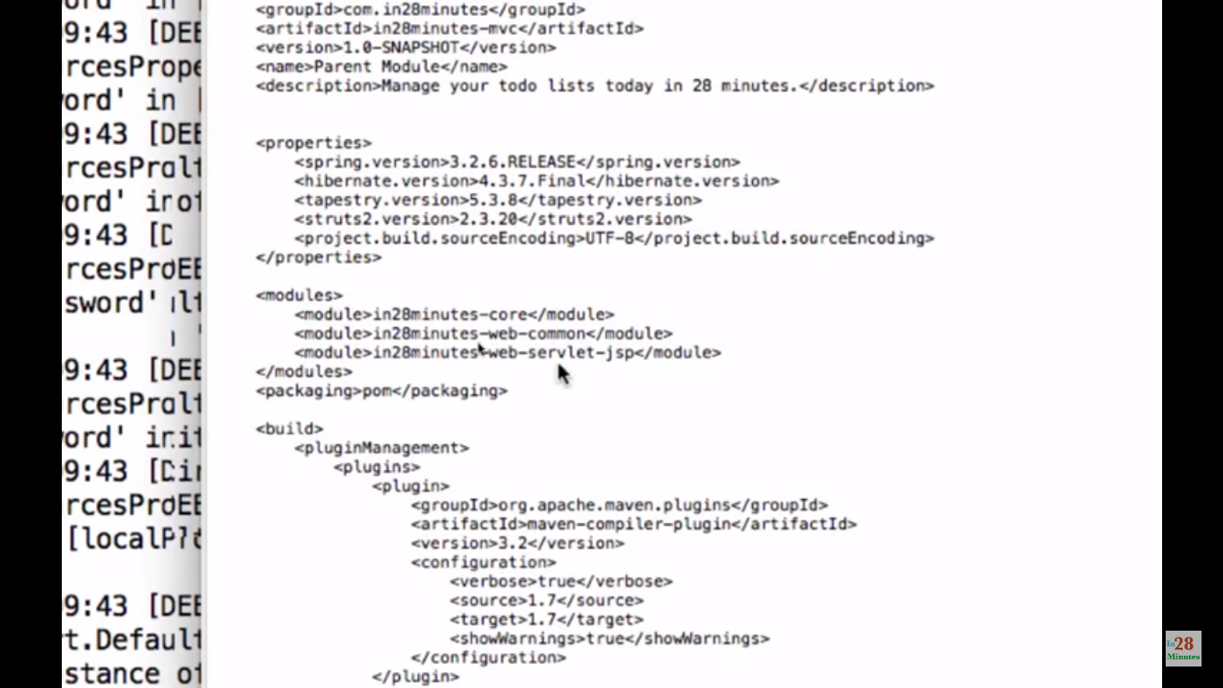

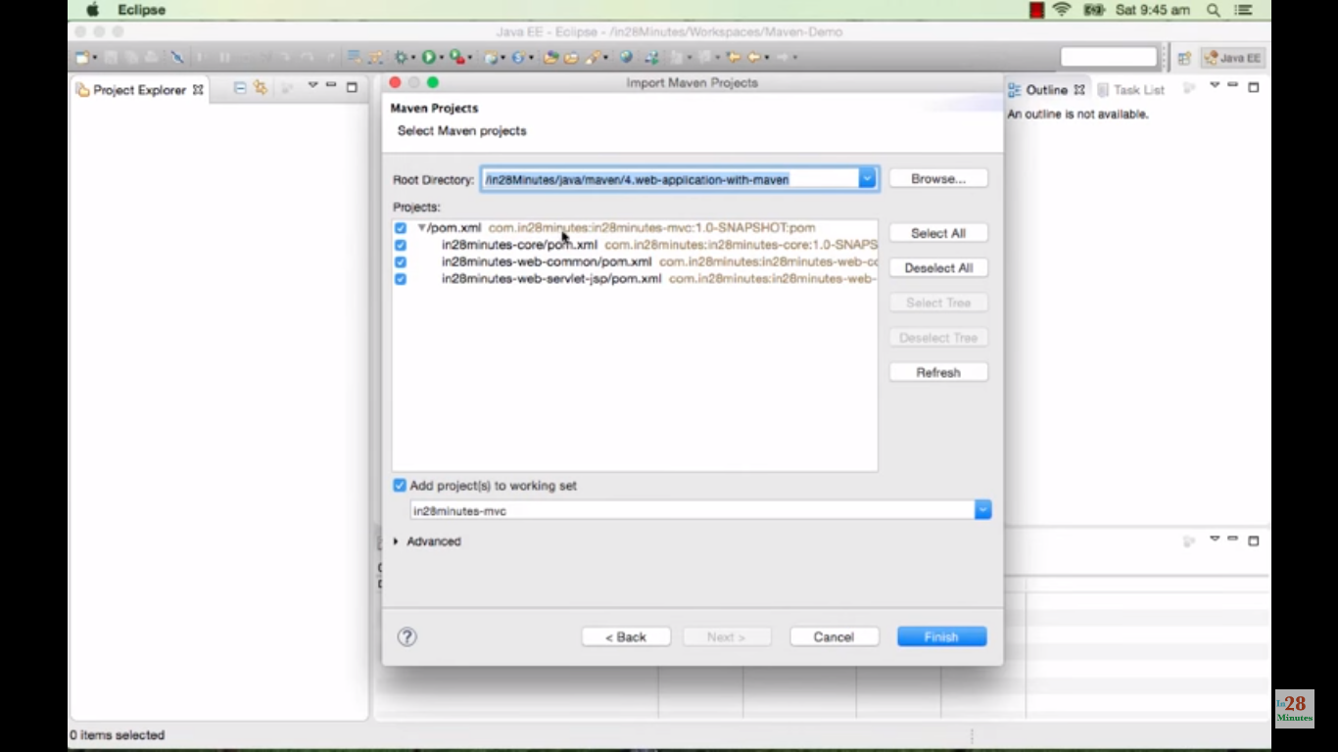

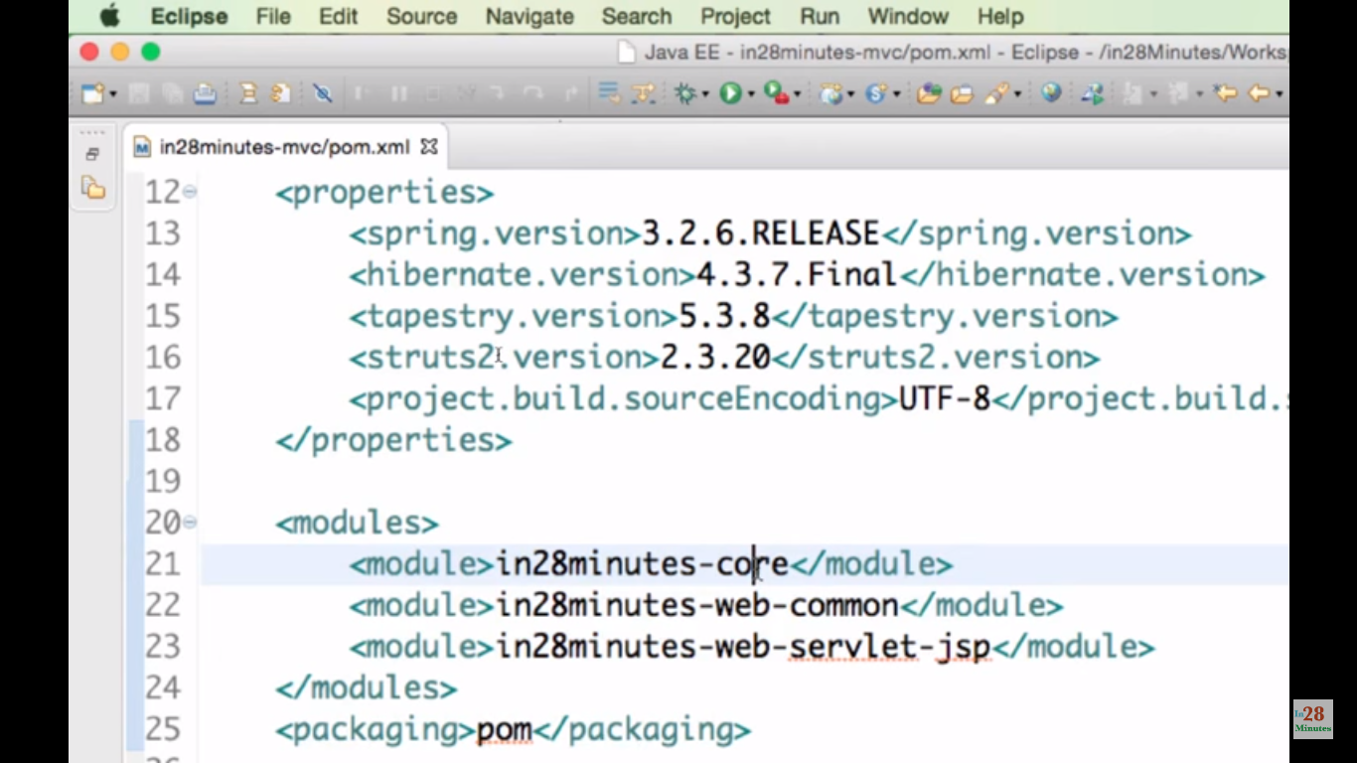

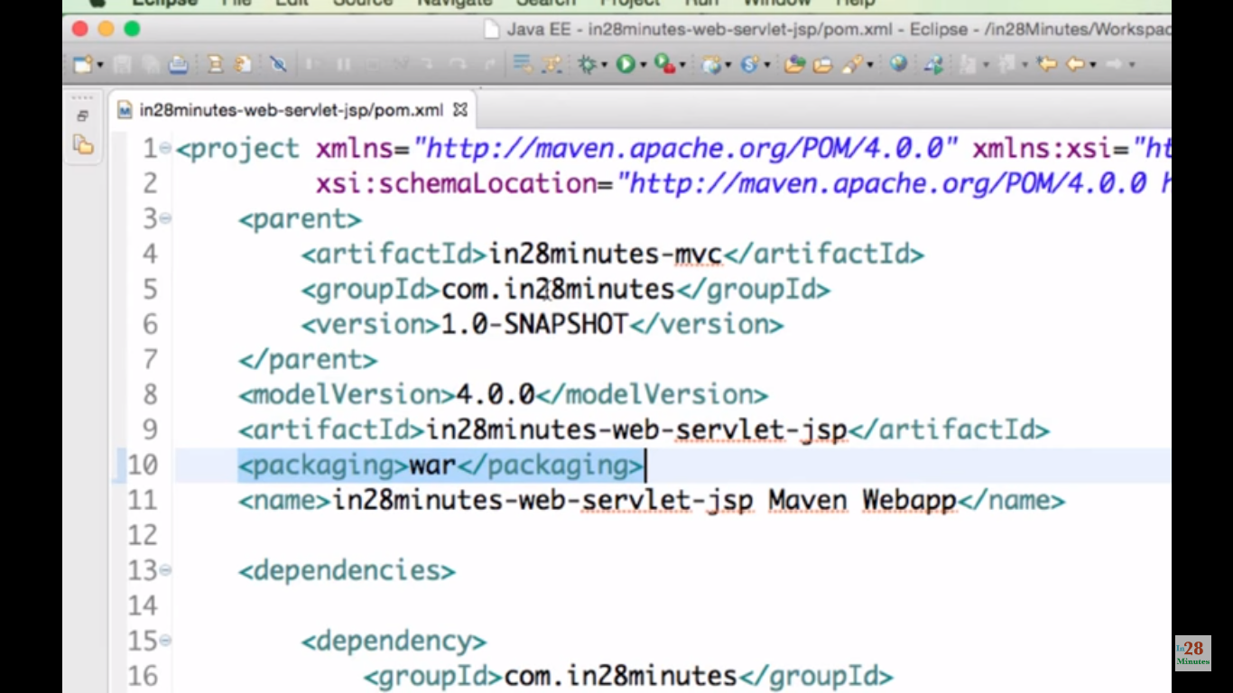

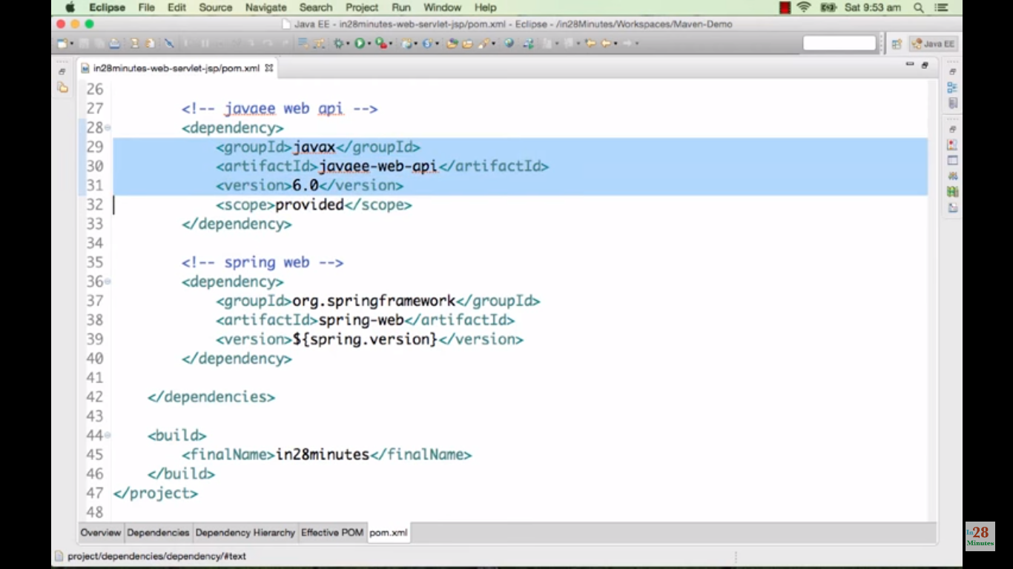

Provided – because this dependency will be provided by web/app server.

Mvn clean install

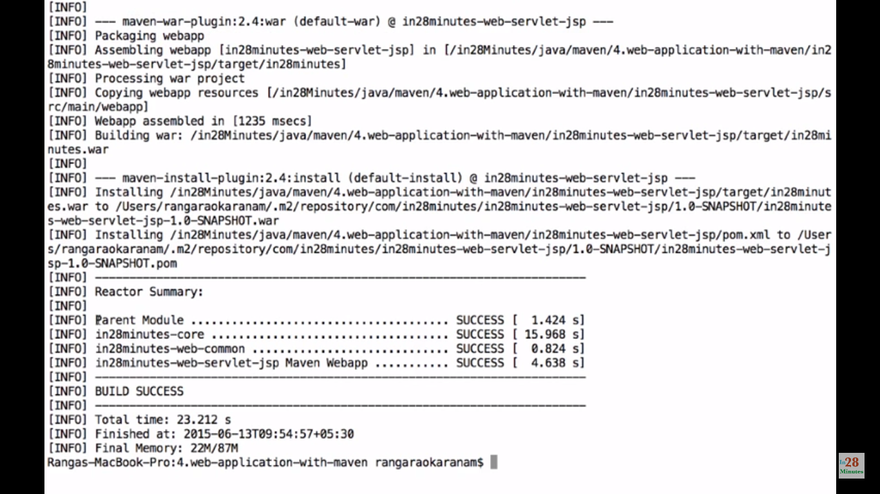

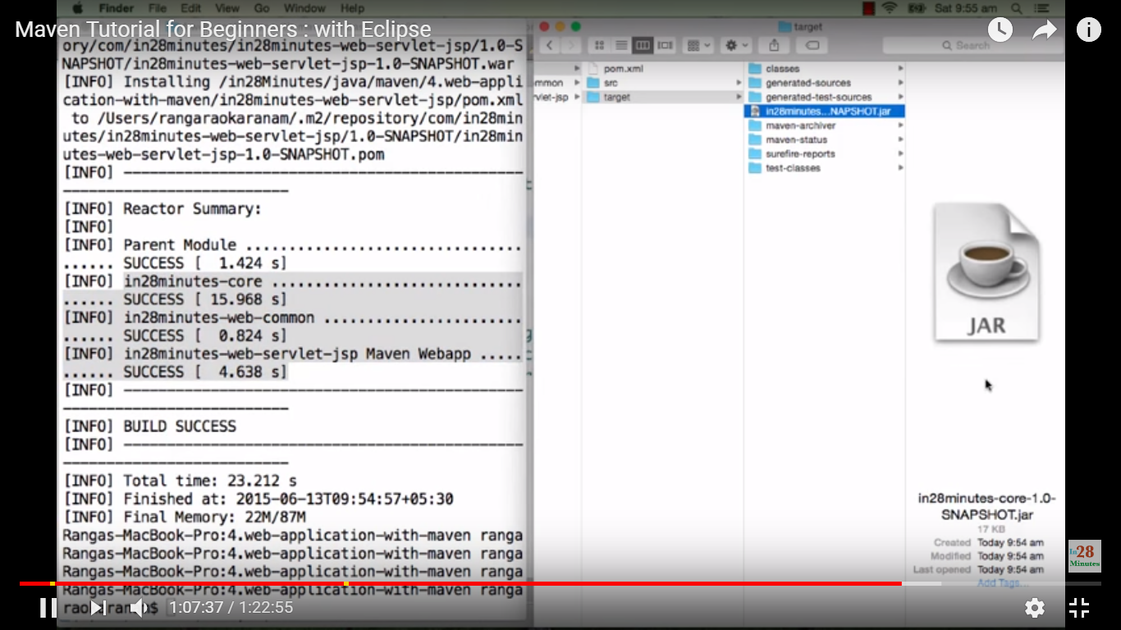

Target of web project(in28minutes-web-servlet-jsp) contains war file. Rest of the projects(core, web-common) contains jar files

Mvn tomcat:run

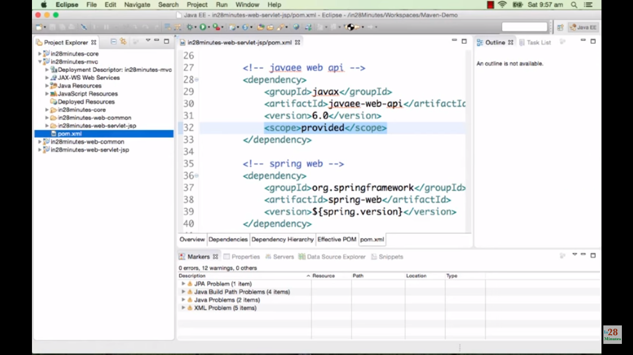

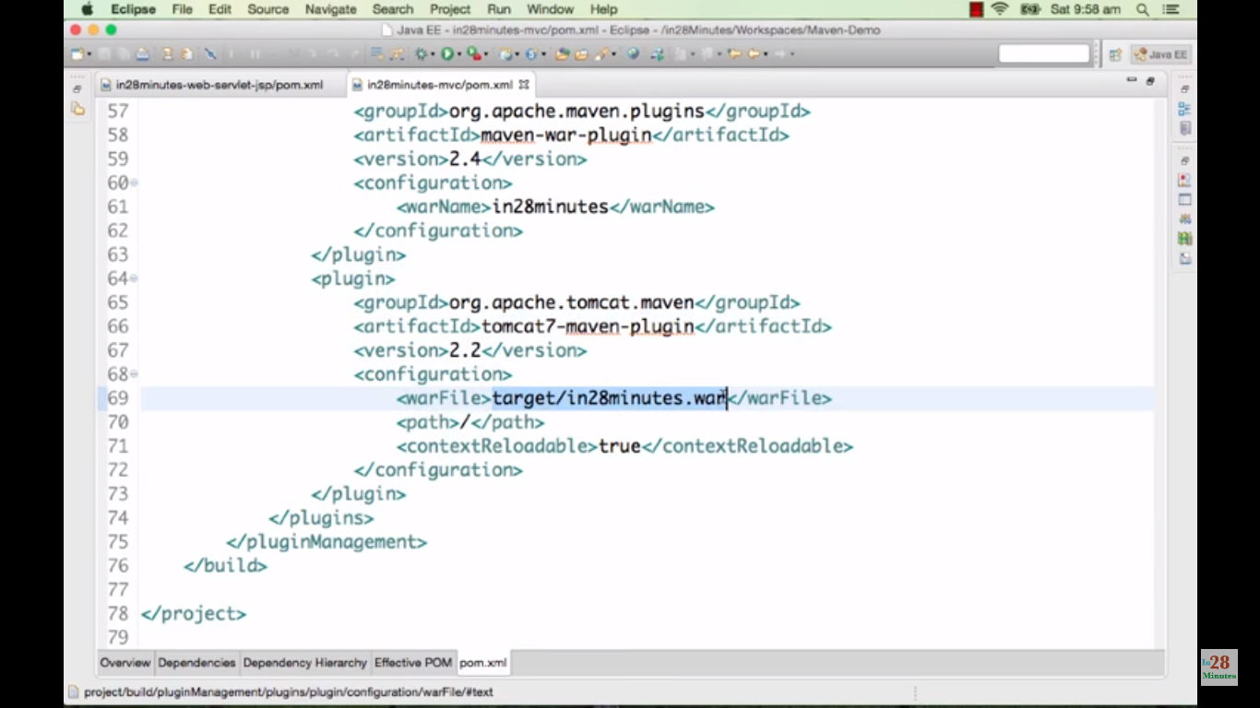

Path is / - localhost:8080/ - then will get the application screen.

Contextrelodable = true - Whenever changes occurred in the project it will automatically deployed in the server.

Mvn tomcat:run – this can be executed only if the plug in is added as above parent pom.xml.

While doing this, entire tomcat server will be downloaded in maven repository and deploy and run it.

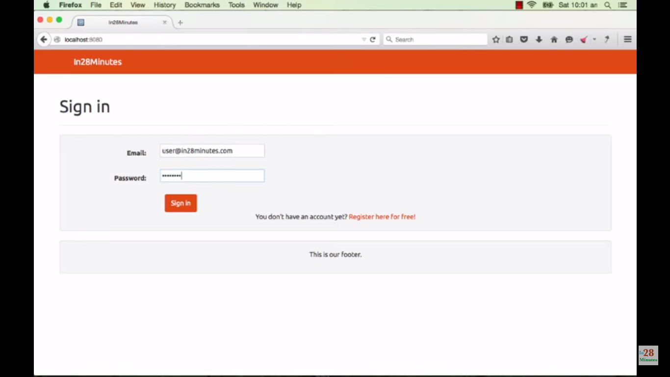

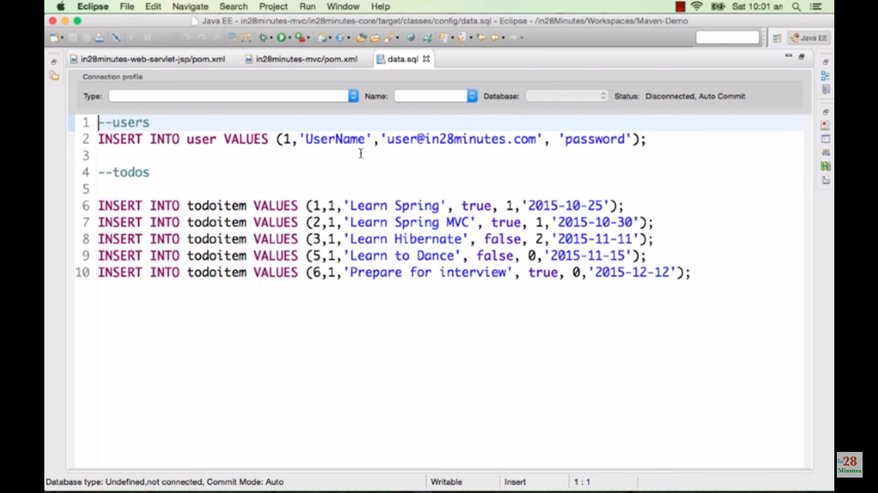

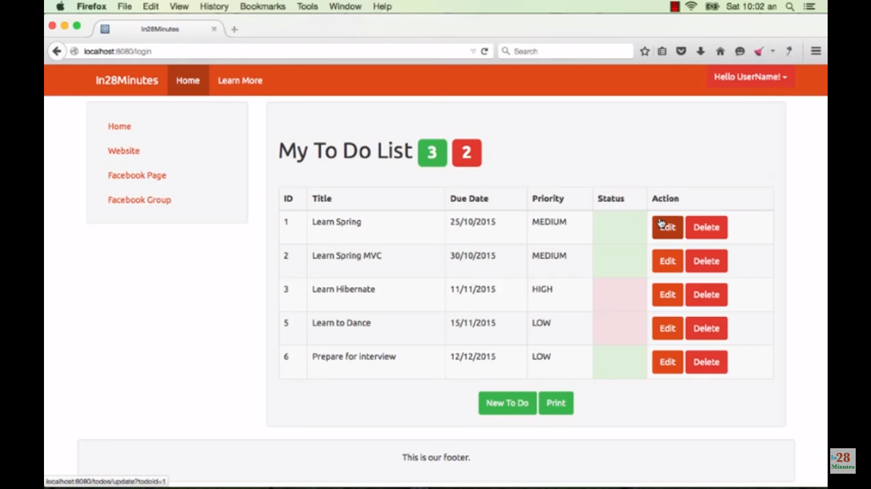

Ctrl+c to stop the tomcat.

Mvn tomcat7:run – to restart again.

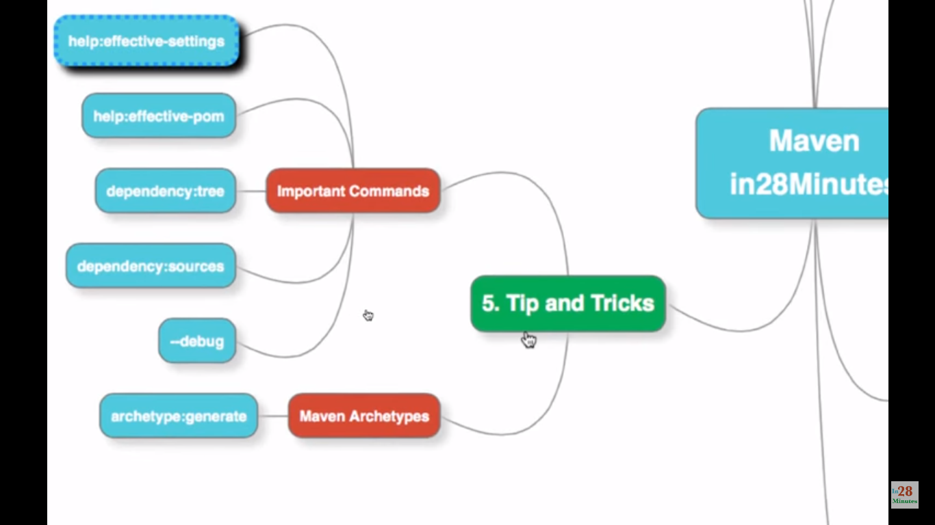

Mvn –X clean to get more details if install is not proper (debug info).

-X – debug

Mvn help:effective-pom – to see all pom details.

Mvn help:effective-settings – show all local maven settings.

Mvn archetype:generate

<https://www.youtube.com/watch?v=yVzi3wuTUE4>

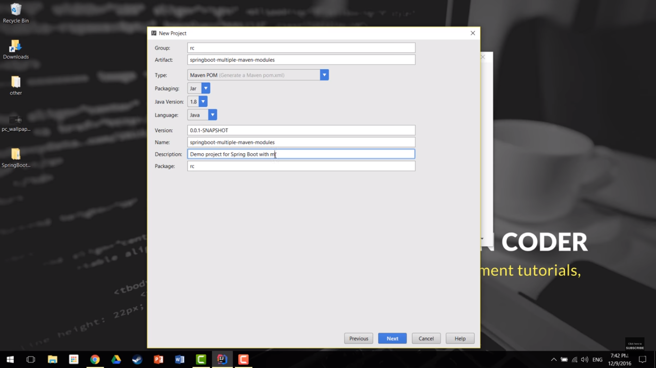

Dependency – web, jpa, h2

